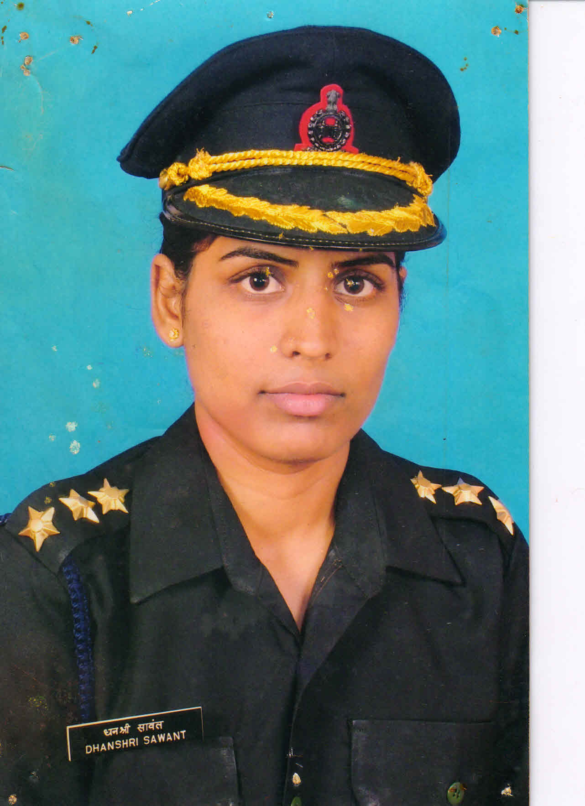
MAJ. DHANSHRI S. SAWANT
MADRASS ENG GP.
INDIAN ARMY
CDT. PRAVIN ASHOK PAWAR
PSI
CISF
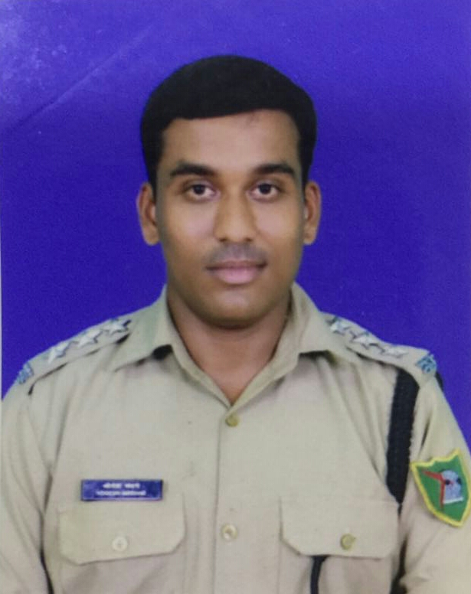
S/UO YOGESH ANNASAHEB MADANE
ASSISTANT COMMISSIONER OF POLICE (ACP)
ANT SMUGGLING CELL,
MINISTRY OF HOME AFFAIRS
GOVT. OF INDIA
GWALIOR (MP)
UPSC 2010 BATCH
ALL INDIA RANK 71
CDT SAMEER JADHAV
ALL INDIA INTER UNIVERSITY
SHOOTING COMPETITION

CDT. RAJAT DHANE
EME
GOLD –BEST IN DRILL.

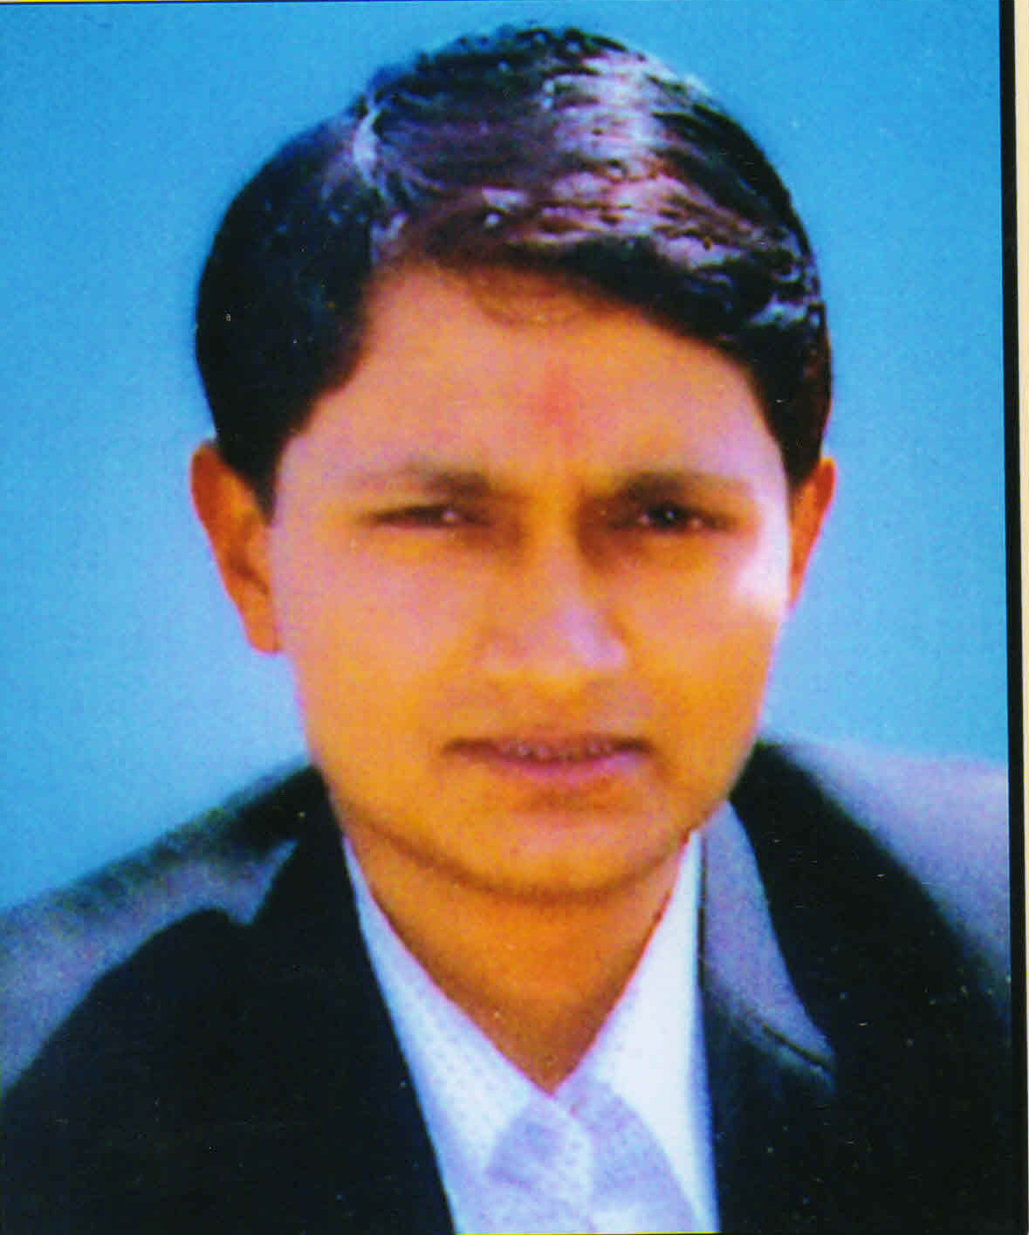
CDT. NITIN PAWAR
JUDGE

CDT.AKASH BENDRE
ALL INDIA INTER
UNIVERSITY SHOOTING COMPETITION.

